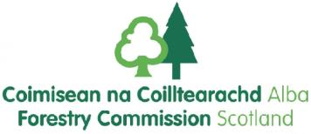

Great Career Opportunities with Forestry Enterprise Scotland
8 New Positions for Apprenticeships in Forest & Timber
Based in Dumfries and Galloway
Background Information
Do you have a passion for working outdoors? Would you like to help shape and preserve some of Scotland’s woodlands and wildlife habitats, so that they can be enjoyed by visitors and local wildlife for years to come? Would you like a job where no two days are ever the same? Have you just left education? Would you like to gain a fully funded industry recognised qualification whilst earning?
Qualification : Apprentices will work toward a Trees & Timber MA Level 2 and 3 qualification. All training & assessment will be provided by SRUC Barony and support and guidance will be available from our experienced workforce.
Based Either in our Dumfries & Borders Forest District (Based at Ae Village) and Galloway Forest District (Based at Newton Stewart).
Upon 2 years successful completion of the apprenticeship, candidates will have the
opportunity to apply for a range of permanent roles within Forestry Enterprise Scotland.
Salary Range £17,028- £17,282
Full Time, 37 hours a week
Duration – 2 Years
Closing date: 10 Dec 2017

Contact point for applicants
HRScotland@forestry.gov.uk

Interview dates
Interview Dates - 16-18th January 2017

Applications on line : www.civilservicejobs.civilservice.gov.uk
Web Site for Background Information ; scotland.forestry.gov.uk
Facebook ; Forestry Commission Scotland

